HOW CLEAN IS TOO CLEAN?

Overuse of disinfectants is causing problems for waste treatment plants.

By BEni Grey DATE SePtember 2020

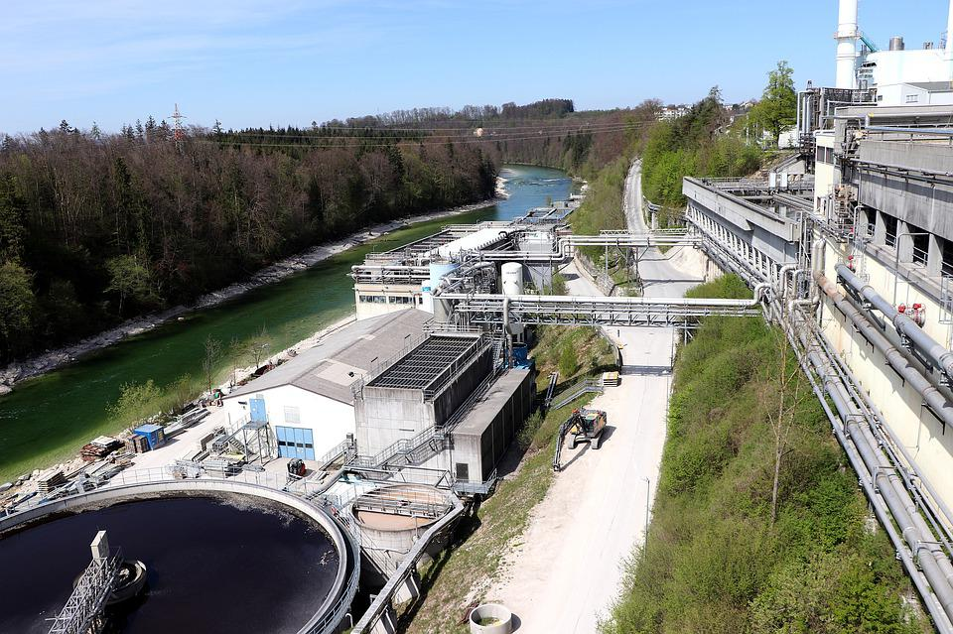
Many wastewater treatments plants use different bacteria to help break down sewage. Now, the overuse of household antimicrobial products could be damaging the effectiveness of these bacteria.
Image from pixabay

Answer the following questions in full sentences:

- What is this news story about?
Scientists are looking at the effects of increasing use of antimicrobial chemicals on the waste water treatment process.

- What was the conclusion of the experiment?
At high concentrations of triclosan (the antimicrobial chemical), bacteria were much less effective at breaking down the harmful substances in waste.

- How could the amount of triclosan in treatment plants be lowered?
By reducing the amount of triclosan that goes down the drain.

- Why may these findings be particularly relevant today?
People are using more antimicrobial chemicals than ever, so there will be more triclosan entering the sewage system.

- Write down the meanings of any words in bold in the article.
Germs – microorganisms that cause disease
Fertiliser – chemicals added to soil that help plants to grow
Antimicrobial – something that works against microorganisms
Thwart – prevent someone or something from doing something
Concentrations – the amount(s) of a substance in a given volume

